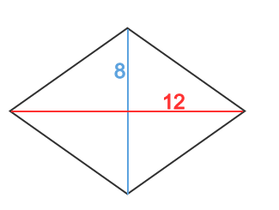
- Find the area

- Find the area
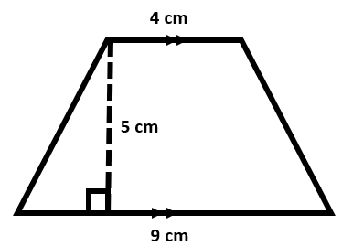
- Find the area
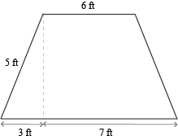
- Find the area
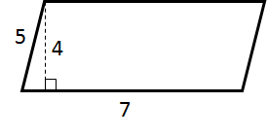
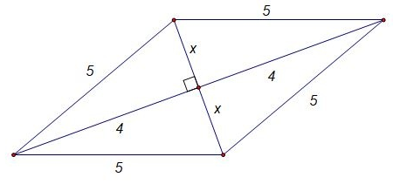
- Find the area

- Plot the points and find the area (-7,5) (6,5) (-9,2) (4,-2)
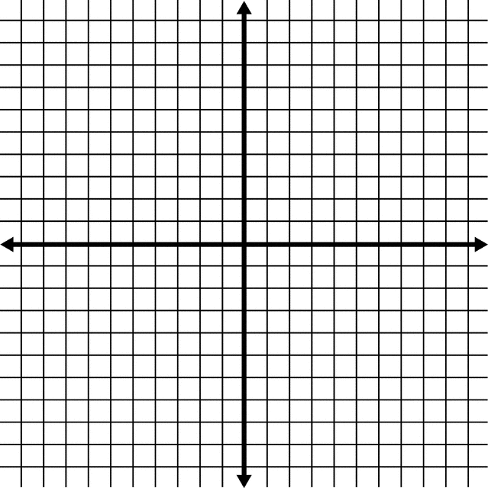
- Find the area
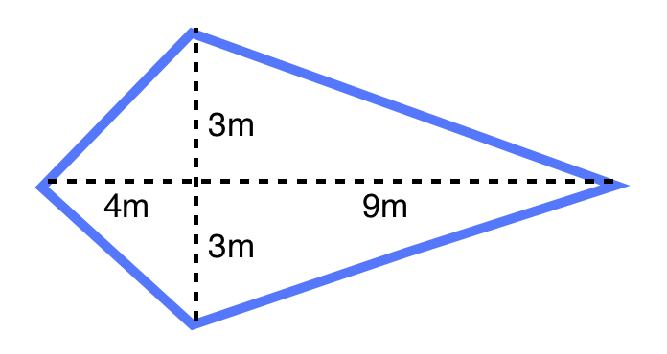
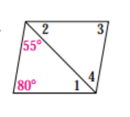
- Find angle 1, 2, 3, 4

- Find angles 1, 2, 3, 4

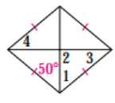

- Find angles 1 and 2

- Find angles 1 and 2

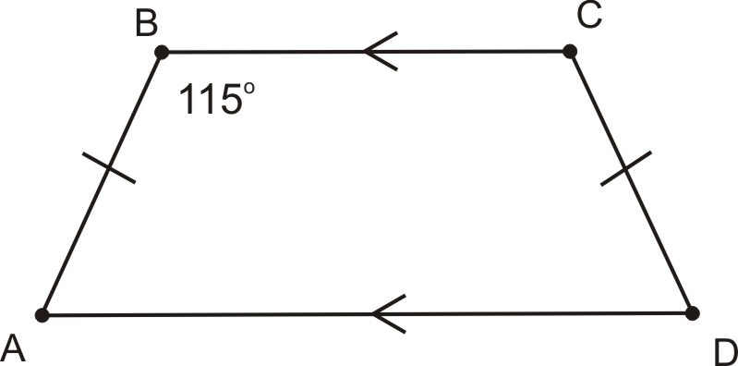
- Find angle A and D

- Find X
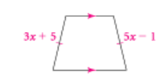

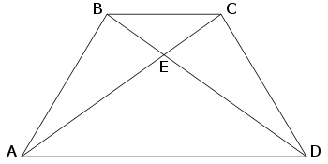
- If BD =2x+26 and AC = 3x – 3. Find X

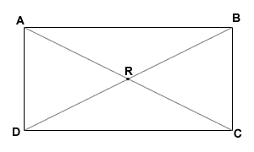
- If AC = 10x-10 and BD = 5x+20, find X.

- Find the remaining missing angles of the trapezoid.
140°
110°

- Which diagonals have perpendicular diagonals?

- Which diagonals have congruent diagonals?

- Graph the points and list the best name of the quadrilateral. (-2,3) (3,8) (4,1) (-1, -4)

Answer Sheet:(turn this sheet in when done, you keep questions) NAME ______________________
1. ___________
2. __________
3. __________
4. __________
5. __________
6. __________
7. __________
8. <1__________ <2 __________ <3 __________ <4 __________
9. <1__________ <2 __________ <3 __________ <4 __________
10. <1__________ <2 __________ <
11. <1__________ <2 __________
12. <A__________ <D __________
13. __________
14. __________
15. __________
16. Left bottom__________ Right bottom _________
17. ________________________________________________________
18. _______________________________________________________
19. _________________________________

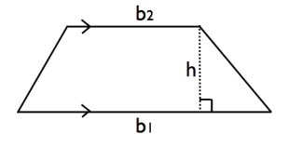
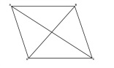
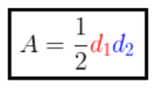
Parallelogram A = bh Kite and rhombus Trapezoid A = $\frac{1}{2}$h(b₁ + b₂)
