Name______________________________________ Day#________
Practice: Graphing Vertical & Horizontal Lines
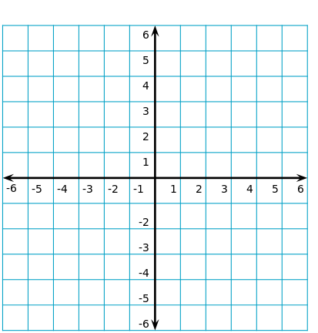
- X= 3 2. Y= 3

3. Y= -4 4. X = -5

